GATHERING

Choral Call to Worship: Alleluia (excerpt) – Wolfgang Amadeus Mozart

Welcome & Land Acknowledgement: Tammy Rottschaefer

Opening Hymn: Out of the Depths, CH #510

THE WORD OF VULNERABILITY

First Testament Reading: Judges 6:33-7:8 – Jimmy Tucker

Sung Refrain: Of All The Spirit’s Gifts to Me, vs. 1 CH #270

Faith Through a Youthful Eye: Deb Murphy

Sung Refrain: Of All The Spirit’s Gifts to Me, vs. 5 CH #270

Sharing the Peace of Christ: Rev. Ben Masters

New Testament Reading: Colossian 3:12-17 – Tammy Rottschaefer

Sermon: Rev. Dan Adolphson

Anthem: Choir – Holy Spirit, Descend On Us – Allen Pote

OFFERING OUR PRAYERS AND OUR GIFTS

Joys and Concerns: Rev. Ben Masters

Sung Refrain: Festival Alleluia – James Chepponis

Pastoral Prayer: Rev. Ben Masters

Offering Reflection: Martha Harrs

Music for Reflection: Jon Sill – Nothing in Common – Jason Robert Brown

Offering Prayer: Martha Harris

THE TABLE OF INVITATION

Invitation to the Table: Katy McFall

Communion Hymn: All Who Hunger, Gather Gladly (v. 1&2), CH #419

Communion Prayer & Words of Institution: Katy McFall

Partaking of Holy Communion
All are truly welcome to partake.

Music for Meditation: Erin Roe – The Lone, Wild Bird from Southern Harmony – arr. Anthony Giamanco

GOING FORTH ALIVE IN VULNERABILITY

Sending Hymn: May the Blessing of God, CH #448

Closing Words: Rev. Ben Masters

Benediction: Rev. Dan Adolphson

Postlude: Erin Roe – Two-Part Invention in F Major, BWV 779 – J.S. Bach, arr. Phillip Keveren

Thank you to all who helped with this Sunday's service.
Worship Leader: Jennifer Stockdale
First Testament Reader: Jimmy Tucker
Preacher: Rev. Dan Adolphson
Deacons: Jim Lee, Valerie Dunham (on-site)
Elders: Martha Harris, Katy McFall
Technicians: Mike Cackoski, Mark Carlson
Music Director: Dr. Caroline Povolny
Section Leaders: Deanna Davis, Jonathan Sill, Tyler Frankhouse
Pianist: Erin Roe
Director of Faith Formation for Children: Deb Murphy
Administrator: Seth Anderson-Matz (seth@fccmpls.org)
Intentional Interim Minister: Rev. Ben Masters (ben.masters@fccmpls.org)
Associate Minister: Rev. Dan Adolphson (dan.adolphson@fccmpls.org)

April 26th, 2026
Fourth Sunday of Easter

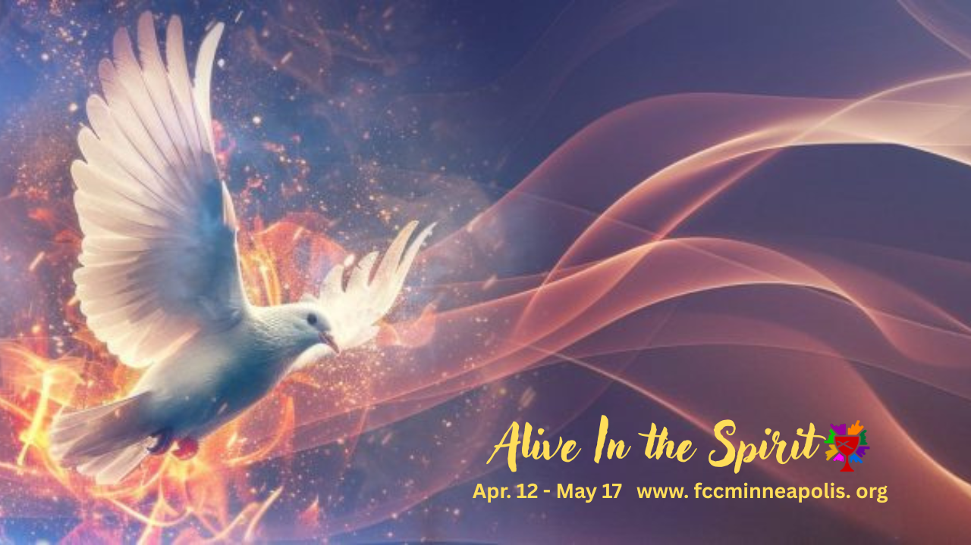

First Christian Church (Disciples of Christ) – Minneapolis
A Welcoming Community of Faith in the Heart of the Twin Cities:
Come to a place you can explore, be curious, and ask questions
SpringHouse Ministry Center
610 West 28th Street | Minneapolis, MN | 55408
www.fccmpls.org • 612-870-1868

Announcements

Please let us know you are worshipping with us by filling out the online worship attendance form. The link is in the Livestream chat, and on the front page of our website, www.fccmpls.org. Prayer requests should be sent to prayer@fccmpls.org.

Communion is offered to everyone.
No matter where you are on life’s journey, ALL are welcome. If you are worshipping with us online, please use whatever you have available to partake of communion from wherever you are watching. If you are with us in person, please come forward to receive communion when invited by the Deacons. If you are unable to come forward, please stay seated and the Deacons will come to you. We use gluten free wafers and grape juice.

Visit the SpringHouse website for more information about how you can support our Minneapolis neighbors during this occupation.

Signups for deacons, elders, and worship leaders are on the front page of the website.

Weekly eBlasts will now only be sent out on Tuesdays and Sundays. Tuesday will include two separate emails—one with prayer requests and one with program and event updates. Fridays will include Sunday service info and weekend announcements.

We will be packing meals for Feed My Starving Children on Sat. May 9, 12 Noon at the Chanhassan location. Sign up link is in the eblasts and on the website.

Pastor Dan will be away this week with Bethany Fellows. He will be checking email; for any pastoral care needs please contact Pastor Ben.

The next board meeting will be in-person, May 17, following worship. Bring a dish to share. The next cabinet meeting will be in-person, June 14, following worship.

FCC Weekly Calendar
All events are held online unless otherwise noted. You can receive the links by signing up for our eBlasts using the purple QR code below.

Sunday, April 26
9 am – 10:00 am – SpringHouse Youth Group
10:00 am – Worship (in person & livestream)

Following worship:
-fellowship in the Gathering Space

Monday, April 27
7 pm – Worship Committee
7 pm – Deacons Meeting

Tuesday, April 28
1 pm – Mission & Outreach

Wednesday, April 29
9 am – Coffee Hour with the Community

Saturday, May 1
9 am – The Breakfast Club
10 am – Grief Support Group @ Westminster Presbyterian Church



Let Us Know You Are Here or
Learn More About FCC Mpls

