First Christian Church (Disciples of Christ), Minneapolis

The COURIER
October 14, 2017

  - What’s INSIDE:

Voices and Views,
Bruce Barkhauer, page 2

FCC News & Notes,
page 3

Easiest Fundraiser Ever,
page 3

UPCOMING Events:

FCC Board Meeting, Tuesday, Oct. 17,
7 pm

Book Club
Thursday, Oct. 19
@ Bobbie Hall's Bloomington home

Brews & Views, Monday, Oct. 23
7 pm@Wicked Wort Brewing, Robbinsdale

Stewardship: Giving, Gratitude, God
Stewardship:
It's all about Giving
It's all about Gratitude
It's all about God.
Our annual Stewardship Campaign launched on Sunday, October 8. Commitment Sunday will be November 5. Each week during worship, the staff will present a variety of skits to give us new ways to think about giving and stewardship.
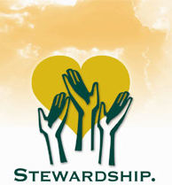

Annual Voices Conference set for Nov. 11
Each year, First Christian Church hosts a community workshop/lecture series entitled Voices: Addressing Issues That Affect the Church and Wider Community. Our audience is the wider ecumenical faith community (clergy, chaplains, lay leaders) in the Twin Cities, and our goal is to provide tools to our colleagues and wider community to help address these issues, through nationally-recognized speakers and partnerships with local organizations and practitioners. Additionally, the registration fee is extremely affordable through the support of FCC's Wholeness Fund.
This year's conference is coming up Saturday, November 11, at Surly Brewing Company from 2 pm to 9 pm and will include a live broadcast of conference headliner Christian Piatt's podcast "Homebrewed Christianity CultureCast." More information is available on our church website.
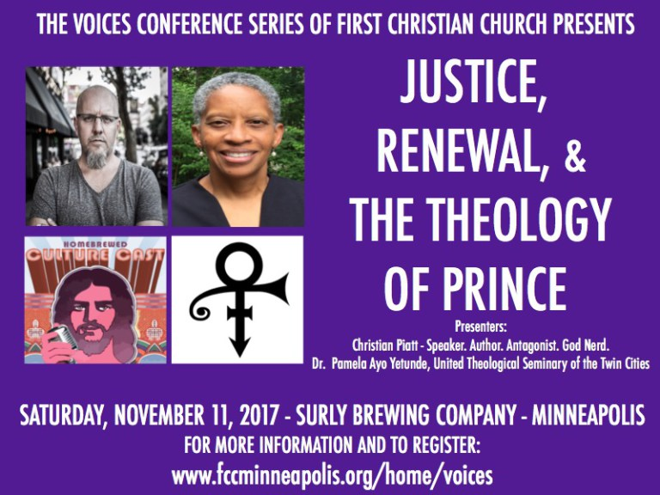

In Our Prayers. . .

Prayers of Sympathy
For Pastor Dan Adolphson on the loss of his adoptive mother Gloria Hines.
For Ann Wolverton and all her family on the loss of her niece Marsha
For Mary Hurlocker's friend who had a death in her family
For Henrietta Smith who lost an aunt and a friend

Prayers of Joy
For Sean Cackoski and his life partner Enrico who were joined in a civil union in Paris
For Ben Tucker getting a new job
For Phil Kinney, back in worship and cancer-free!

Prayers of Concern
For Bryan Feille undergoing eye surgery
For Kevin Berkey having dental work
For Elizabeth Larson
For all our homebound members Elaine Moe and Bev Singewald.

Prayers for the World
For the victims of the Las Vegas massacre and for our country to have the courage to reckon with the scourge of gun violence

Page 2
October 14, 2017
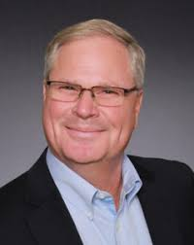

Voices and Views
Bruce A. Barkhauer

Note: For this reflection, we have literally borrowed a page from last year's Stewardship Campaign, which featured Community of Prayer, a devotional booklet written by Bruce Barkhauer, who served as the first Minister for Faith and Giving for the Christian Church (Disciples of Christ).

Finding Your Heart
For where your treasure is, there your heart will be also.
Matthew 6:21

I confess that for years I understood this text as saying my treasure would naturally follow my heart. It was just the way I had heard it as a child. It was only as an adult that I came to realize the text says exactly the opposite. My heart will follow my treasure, not the other way around.

Jesus dares to say that your checkbook is a theological document. Look at your EFT statement at the end of the month and you will know what matters to you. Your money flows to what you love. Find your money and you will find your heart.

This would even apply to our congregations. The church budget is also a theological document. To what does our money flow? Are we caring for ourselves or are we seeking to impact the lives of others? Does our financial report show that we tithe as a congregation from the resources we receive to causes outside of our own concern?

In a season of stewardship preparation, you have to ask yourself, can you find your heart for God amidst the trail of debit and credit card transactions? Do the ledger entries demonstrate a concern for justice, a desire to bring wholeness, and the hope that no one should be without food, clean water and shelter? Or do they say something else?

In a season of stewardship preparation, you might ask yourself, where is your heart and is it where you hoped you would find it? Would a little more treasure invested in the Realm of God reflect what you would like the answer to be?

God, I desire my heart and my treasure to be less in conflict and more in line with you. Amen

The easiest fundraiser ever!
FCC News & Notes

Page 3
The Courier
We’re starting another round of the easiest fundraiser you’ll ever do! We’re not asking for your money, we’re just asking you to spend it a little differently than you normally would. Before heading to the store to do your everyday shopping, pick up a gift card from us. The SpringHouse mission fund will get a percentage of the sale while you still spend the amount you normally would have. Cards are available for many different restaurants, gas stations, stores, and even travel and entertainment sources.
New bass section leader
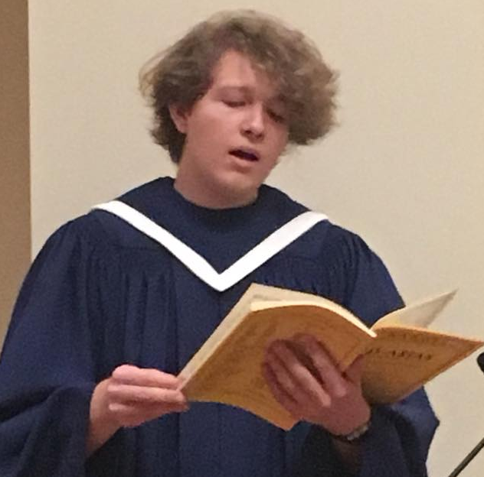
Tanner Vanderkrabben is the new bass section leader for our Chancel Choir. Tanner is a sophomore in Music Education at the University of Minnesota. He hails from Orland Park, Illinois.

Invitation to Yoga
A new yoga class has started on Mondays at SpringHouse. The class takes place in the North Sanctuary from 6-7 pm, and FCC members are cordially invited to learn and practice yoga. Contact Deb Murphy in the church office if you have questions.

Sheridan Story project needs Friday volunteers
Children in food-challenged families at nearby Whittier School find bags of food in their lockers every Friday to take home to their families for the weekend. FCC participates in this program through volunteers who take an hour on Friday afternoons to place the bags in the children's lockers. Sign-up sheets are in the FCC office and volunteers are needed for the school year.

Can this really make a difference?

Let’s look at an example. I buy a $100 gift card for Cub Foods. It has a 4% donation rate, so SpringHouse gets $4. That doesn’t seem like a lot. But I can easily spend 4 of those a month, so now the church gets $16. Let’s say 20 people all do this – now we’re up to $320/month! If 100
people do it, that’s $1600/month!

Sounds great, how do I get started? There are several ways to participate in this fundraiser:

Online: Visit ShopWithScrip.com, enter our code (BF16DF4B443L6), and create an account. There you can see all of the card options available and submit your order. Pay the church, and we will deliver your card(s) to you at church.

For the “computer challenged”: Pick up an order form at church and fill it out to let us know which cards you would like, and in what amounts. Pay the church, and we will deliver your card(s) to you at church.

Gift cards are great for:
Classroom supplies
Thanksgiving shopping
Christmas shopping (for you or a gift)
Wedding gifts
Baby showers
Thanking the kid who picks up your mail
Your own personal every day shopping
…and more!

We will place two orders this fall. The first will be due by Oct 8, and the cards should arrive back to church by Oct 22. The second order is due Nov 26, and should be back by Dec 10.

If you have questions, contact Becki Whitaker at purplepercussionist@gmail.com or 651-686-6571. Thanks for helping us support SpringHouse missions!

Reflections on the Word
I Samuel 16: 11a "Samuel said to Jesse, 'Are all your sons here?' And he said, 'There remains yet the youngest, but he is keeping the sheep.'"
Abel, the righteous of the first two brothers, was a shepherd. Abraham, Isaac, Jacob, Rachel, and Moses were all shepherds. David inherits this nomadic occupation as well as the Near Eastern metaphor of the shepherd-king, a good ruler who cared for subjects as a shepherd cares for sheep. Some historians think that the royal scepter evolved from the shepherd's crook.
Loving God, You are my Shepherd, I have all I need. Goodness and mercy shall surely follow me all the days of my life. Amen.
By Gail Ramshaw, Treasures Old and New: Images in the Lectionary
October 14, 2017
Page 4

Sundays at First Christian Church

Worship at 10:30

Before Worship After Worship
Children’s Classes, 9:15 am Fellowship Time 11:45
Joint Adult class 9:30 am

First Christian Church (Disciples of Christ), Minneapolis, is a partner church at SpringHouse Ministry Center
Narrative Lectionary
For Sunday, October 15
God Calls David
I Samuel 16: 1-13

A Welcoming Community of Faith in the Heart of the City
Ministry Team
Dan Adolphson, Associate Pastor, dan.adolphson@fccmpls.org
Julie Andrix, Faith Community Nurse, fcn@fccmpls.org
Rick Bowman, SHMC Building Manager
Adam Conrad, Music Director & Composer-in-Residence
Pearl Evans, SHMC Child Care
Laurie Feille, Senior Pastor, pastor@fccmpls.org
Martha Harris, Courier Editor, harrismartha@mac.com
Deb Murphy, Office Manager & Director of Spiritual Formation of Children and Youth, deb.murphy@fccmpls.org
& SHMC Building Coordinator, events_SHMC@fccmpls.org
Maria Thieling, SHMC Child Care
Mike Vasich - Pianist

FCC Office Telephone: 612.870.1868
www.fccminneapolis.org
E-Mail: office@fccminneapolis.org
Christian Courier is published bi-monthly. Send items and ideas to church office or to Martha Harris
harrismartha@mac.com
Next issue deadline is Sunday, October 22, 2017
First Christian Church of Minneapolis (Disciples of Christ)
610 W. 28th Street
Minneapolis, MN 55408

