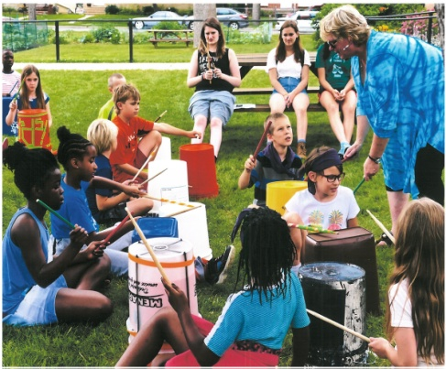 | Peace ~ Salaam ~ Shalom  South Minneapolis Day Camp  June 27 – July 1, 2016  We’ll be learning about our call to be peacemakers in a world of many faiths through music, story, art, play, field trips, and more!

What: A progressive ecumenical summer day camp experience offering faith formation in a fun, safe, Christ-centered and relational setting. Includes worship, crafts, games, lunch and field trips.
When: June 27-July 1, 9am-4pm, M-F
Where: Bethel Lutheran Church, 4120 17th Ave S, Minneapolis MN 55407
Who: 4-year-olds to 8th graders
Cost: $25 per camper, $60 max for families. Scholar-ships available. Make checks payable to Our Saviour’s.
Opportunity to give more: Our registration fee doesn’t cover costs. If you can afford it, please consider giving more. We’ll use your donation to stipend youth volunteers and for supplies.
Sponsoring congregations: Our Saviour’s Lutheran, Bethel Lutheran, Calvary Lutheran, First Christian (Disciples of Christ), First Congregational UCC, Zion Lutheran, Judson Memorial Baptist, University Lutheran Church of Hope, Salem Lutheran, St. John’s Lutheran, Augustana Lutheran, Lyndale UCC, Lake of the Isles Lutheran, Living Table UCC, Lake Nokomis Presbyterian and Living Spirit UMC.

Registration Deadline: Please register your child(ren) by June 1. Mail or otherwise bring this form along with your payment to: Pr. Martha Bardwell, Our Saviour’s Lutheran Church, 2315 Chicago Ave, Minneapolis MN 55404.
Child’s Name._______________________________________________________________ Gender:_________________
Birth Date _______/______/_____ Age _________ Grade Entering Fall ’16: ___________
Address: ___________________________________________________________________________________________
If your child is affiliated with a church, which one? __________________________________________________________
Responsible Parent/Guardian: __________________________________________________________________________
E-mail address: ____________________________________ Daytime Phone: __________________________________
Evening Phone: ____________________________________ Cell Phone: ______________________________________
Address ___________________________________________________________________________________________
Name of additional emergency contact: ____________________________________ Phone: ________________________
Relationship to camper: __________________________________________________

Additional individuals authorized for drop-off and pick-up:
Name: _______________________________________________________ Phone: ______________________________
Name: _______________________________________________________ Phone: ______________________________
Name: _______________________________________________________ Phone: ______________________________
Health and medical information
Is Camper covered by health insurance? Yes / No (circle one)
Company__________________________________________ Policy Number: _____________________________
Group Number: _______________________________________________________________________________
Does your child have any allergies (including food allergies)? Yes / No (circle one)
Please list and describe reaction and management: __________________________________________________
____________________________________________________________________________________________
Will your child need to take medications during Day Camp hours (9am-4pm)? Yes / No (circle one)
Medication name |  | Dosage | Time taken | Reason for medication:
List all medical conditions, physical or learning challenges, any emotional or behavioral concerns, strategies for better-engaging your child, and/or other relevant information:
__________________________________________________________________________________________________
__________________________________________________________________________________________________
Parent/Guardian Authorization:
- In the event my child needs immediate medical attention for injuries receives while participating in Day Camp, I authorize the staff to give my child reasonable first aid, and to arrange the transportation of my child to a healthcare facility as needed. If I cannot be reached, I hereby give permission to the physician selected by the Day Camp to hospitalize, secure proper treatment for, to order injections, anesthesia, or surgery for my child as named on this form. I agree to the release of any records necessary for treatment, referral, billing or insurance purposes. Information received may need to be shared with medical providers.
- My child has permission to be transported as needed for field trips, inclement weather, or late pick-up. I also give permission for my child to participate in walking field trips.
- During morning drop-off, the responsible party will indicate in writing who will pick up the child at the end of Day Camp. The responsible party will notify Day Camp if that information changes during the day.
- If my child requires the use and administration of an epi-pen, it is my responsibility to ensure that the epi-pen is on my child or in his/her personal belongings each day of camp. If Day Camp staff are required to administer and use the epi-pen, I agree to forever release and discharge the Day Camp staff from all liability arising out of or resulting from use or administration of the epi-pen.
- I give permission for Day Camp staff to administer sunscreen as needed.
- I voluntarily waive any claim against the sponsoring organizations/congregations and volunteers.
- I consent to the use of photography of my child in appropriate Day Camp publicity.
(Signed) _______________________________________________________________________________________ Date: _____ / _____/ 2016

