-
The Courier
February 20, 2016
First Christian Church (Disciples of Christ), Minneapolis

  - What’s INSIDE:

Message from
Pastor Laurie Feille,
page 2

Health at First
page 3

Search Committee Survey,
page 3

March calendar,
page 4
Black History feature, page 5

UPCOMING Events

Elders Meeting, 5 pm, Sunday, February 21

Book Club at Barb Creighton’s, 7 pm, Monday, February 22,

Lenten Soup & Supper, 7 pm, Tuesday, February 23 at Gethesemene Episcopal

The world calls: Give to Week of Compassion
In a world where communities are being displaced by the catastrophes of war, famine and natural disasters, the Church is called to stand in solidarity with refugee communities as they seek to move behind the trauma of displacement and toward a new life of well-being.

Through the Week of Compassion offering, Disciples work to be in solidarity with suffering people throughout our nation and throughout the world. This year's Week of Compassion theme is taken from Ruth's promise to Naomi of "solidarity", and it stands as a challenge for Christians to intentionally walk with refugees as they seek to build a new home in strange lands.

"Where you go I will go, and where you stay I will
stay. your people will be my people and your God
my God. (Ruth 1:16)

Offerings to Week of Compassion are used effectively. For every $1 contributed,
50¢ to emergency response
25¢ to sustainable development
8¢ to refugee and immigration ministries
8-10¢ to ecumenical partners, mission stations, and
volunteer work grip grants
6-8¢ administrative costs

Week of Compassion offerings will be February 21 and February 28. Give generously!

Easter Flower “donations” will support MN FoodShare
Once again, the worship team will provide the flowers for Easter, while members of the congregation, instead of purchasing flowers, are being asked by the mission team and the worship team to make a donation to Minnesota FoodShare. Make the check payable to First Christian and write ‘FoodShare” in the memo. Starting March 6 (March is Minnesota FoodShare Month), you will find green envelopes in your bulletins and a form to fill out indicating the person your donation is in honor or memory of. Those names will be printed in the Easter Sunday bulletin.
In Our Prayers

Prayers of Sympathy
For Tim Leach on the loss of his brother Curt
For Jon Krengel on the loss of his grandmother

Prayers for Concern
For Ali Hesano’s friend Danelle
For the Tucker family
For Jimmy Burnett’s sister Pam
For Garry Hesser’s colleagues and brother
For all our homebound members, including
Doris Helvig and Bev Singewald

Prayers for World
For the people of Flint, Michigan in their water quality emergency
For world and local leaders that they can find a way to peace

A message from
PASTOR LAURIE

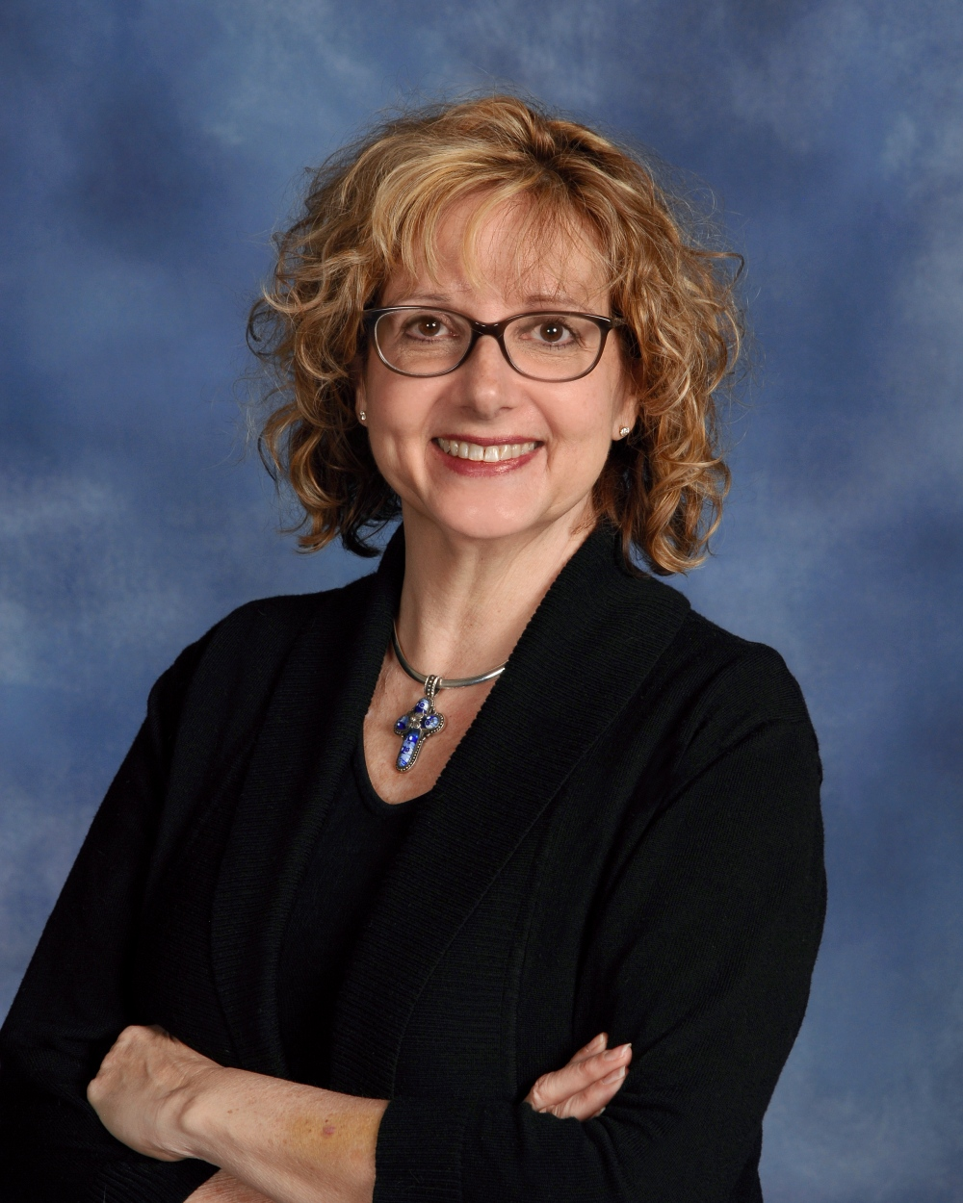
February 20, 2016
Page 2
Page 2
July 25, 2015

Sunday afternoon Ann Wolverton and I played
hosts to the Civil Society Open House. Due to the wonderful space we have here at SpringHouse, the
Civil Society decided to invite people to learn more about them by gathering with us instead of at their offices. It was heartbreaking and heart warming to hear the stories of the people that they, as lawyers, have helped to escape from sex trafficking. Linda Miller, the Executive Director, could not thank us enough for hosting their Open House.
As with hosting any event Ann and I found ourselves running back and forth between the kitchen and the South Sanctuary. It was during these times of running back and forth and running the dishes through the dishwasher that I met another group of wonderful people. Vida Abundante en Cristo, a Latino/Latina church, is meeting in the North Sanctuary on Sunday afternoons. People of all ages were coming up the stairs to meet for worship.
When the Civil Society Open House wound down I was in the kitchen as Vida Abundante en Cristo ended their worship. They gathered in the Gathering Space to share a meal together. A woman, whom I assumed to be a member, came into the kitchen to apologize to me for how loud a few children had been in the Gathering Space during their worship time. I told her that I had not noticed since we have loud children at SpringHouse on Sunday mornings. We talked for a few more minutes and then I commented on how wonderful the food smelled that they had brought to share with each other. The next thing I knew I had a plate of homemade, yes homemade, ceviche! It was the best ceviche I have had since I left Texas.
So, I’m standing in the kitchen, running dishes through the dishwasher, eating ceviche and almost crying because the food tasted like I was standing in Texas. At this point I strike up a conversation with another woman from the church who is warming something in the microwave. During the conversation I discover that she made the ceviche (I almost asked her to marry me—sorry Bryan!) and that the woman who had apologized for the noise level of the children was the Pastora of the church. I found Pastora Landy Rivero and we spent some time talking. She is an amazing Pastora and she is beyond grateful to rent space at SpringHouse!
I did finally remember that Ann was in the South Sanctuary cleaning up (Thank You Ann!) and I went in to help her and to say goodbye to the Civil Society staff who were there gathering their belongings. I went to return something to the office area and ran into several people who were looking for the Garden Sanctuary. They were at SpringHouse to attend a Narcotics Anonymous meeting. I walked them to the Garden Sanctuary and as I turned to go back up the stairs I heard “Thank you so much for letting us meet here.” I turned back and said “No, thank you for meeting here.”
If you ever wonder if SpringHouse is being used other than on Sunday mornings I invite you to come and spend some time in the Sun Room, the Gathering Space or even come and run some dishes through the dishwasher. As I drove home late Sunday afternoon I was overwhelmed by the amount of thankfulness and life that had filled SpringHouse all day long. Thank you for being a church that decided to do church in a new and different way. That decision has brought life to more people than we know. I am blessed to serve alongside each one of you. Much love and peace, Laurie
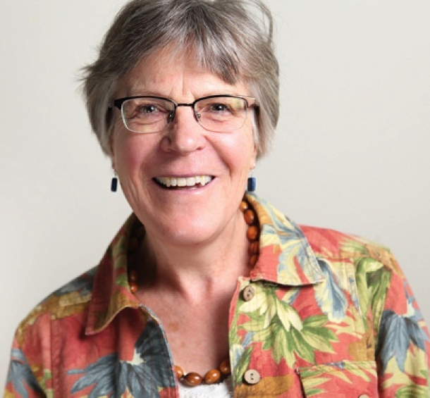
Health at First
Julie Andrix,
Faith Community
Nurse

The Courier
Page 3
Page 3
Search Committee seeks input for General Minister
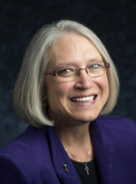
Sharon Watkins is stepping down from her post as General Minister and President of the Disciples of Christ, because her 6-year term has ended. The search process for our next General Minister and President is underway and the Search Committee is seeking input from Disciple clergy and lay people in this process. Below you will find a link to a short survey on the work of the General Minister and President. The Search Committee hopes to hear from you — What qualities do you think we need in a General Minister and President? How important are the current roles to you? Is there a role not mentioned that you feel should be included?

Discover the balance in your heart as February is National Heart Health Month. Also, Lent began February 10 and generally people give something up during Lent.
How about making a heart healthy goal you can
keep? Would you need to give something up to attain your goal? To begin with, we are created in the image God
and in understanding this, we can glimpse the level of health, wholeness and well-being that God means for us to experience. Remember, you get where you want to go one step at a time. The small steps are what change the behaviors for the long term.
Let’s say you have high blood pressure and take a prescribed medication. The problem is that you forget to take the medication half the time. A very general goal might be to say, "I will take my medicine.” How is this goal going to be attained? A more specific, reachable goal might be to have a consistent time of day and location to take it and keep the medicine in a weekly pill box. These simple actions may make a big difference. Name the specific habit that you want to form and picture yourself doing it, one step at a time.
With God's help, let's reach goals together!
Julie Andrix
With your help, the committee’s goal is to further define the gifts needed to lead our denomination. Please take 2-3 minutes to complete and submit your answers by February 29. Be assured that all the answers you provide will be kept in the strictest confidentiality.

https://www.surveymonkey.com/r/GMPEnglish

Reminder of upcoming Lent events
Tuesday, February 23, 6 pm soup supper and program at Gethsemane
Episcopal Church
Tuesday, March 1, 6 pm soup supper and program at SpringHouse with
folks from Gethsemane Episcopal Church
Tuesday, March 8, 5:30 meal at Loaves and Fishes followed by a visit to
St. Stephen’s Housing Services offices where a panel of Simpson Educators (people who are homeless) and Simpson staff will help us understand more about what is happening, what is needed and what we can do to make a difference about Homelessness.
Thursdays, 10 am: Lenten Study in Lydia

Prayer Vigil
We will be having a Prayer Vigil March 24th-25th as part of our Holy Week activities. It will start at 8 pm on Thursday evening at SpringHouse in the North Sanctuary. It will continue overnight in people’s homes, and then be at SpringHouse again at 9 am, ending at 3 pm. If it’s easier, anyone may pray at home during any of the time slots. Karen Kandik is organizing the vigil. Watch for information about sign-up.
March 2016  First Christian Church |  |  |  | Sunday Morning Schedule  9:00 Spiritual Formation Classes  10:30 Worship  11:45 Fellowship Time in Gathering Space
 |  | 1  6 pm Lenten Soup/Study with Gethsemene | 2  8 am Narrative Lectionary Bible Study  10:30 FCC Staff Mtg.  6:30 Handbells  7:45 Choir |  | 3  9 am Ecumenical women’s  ministry  10 am Lenten Study  7 pm Pastor Dan PRC | 4 | 5  9 am Men’s Bible Study  6 pm First Saturday Family Partnership
7  North Sanctuary  Noon – Children’s Ministry Team | 8  3 pm Carter Circle | 8  6 pm Lenten Soup/Study at Loaves and Fishes  7 pm SH Finance committee | 9  8 am Narrative Lectionary Bible Study  2:00 Mission and Outreach  5:30 Finance Committee  6:30 Handbells  7:45 Choir |  | 10  9 am Ecumenical women’s  ministry  10 am Lenten Study | 11  7 pm Irreverent Movie Night | 12  9 am Men’s Bible Study  10 am Lenten Brunch  (2 am Daylight Savings Time Begins – Spring Ahead 1 hour)
13  North Sanctuary  Noon – SH Green Team | 14 | 15  6 pm Worship Committee  7 pm Board Meeting | 16  8 am Narrative Lectionary Bible Study  10:30 FCC Staff Mtg.  6:30 Handbells  7:45 Chancel Choir |  | 17  9 am Ecumenical women’s  ministry  10 am Lenten Study  7 pm SHMC Board Mtg | 18  2 pm First Saturday Partner Planning | 19  9 am Men’s Bible Study
20 Palm Sunday  North Sanctuary  9:15 am – Peeps Diaoramas  11:45 SH Activistas  Noon Blood Pressure Checks  5 pm Elders Mts. @ Hillsteads | 21  6:45 SH Building Committee | 22 | 23  8 am Narrative Lectionary Bible Study  6:30 Handbells  7:45 Chancel Choir |  | 24 Maundy Thursday  6:30 pm Labyrinth and Prayer Stations  9 pm Prayer Vigil Begins | 25 Good Friday  Prayer Vigil until 3 pm  6 pm Soup Supper  7 pm Good Friday Service | 26  9 am Men’s Bible Study
27 Easter Sunday  North Sanctuary 6:45 Sunrise Service on Patio  9 am Youth Pancake Breakfast  8 am First Service  10:30 am Second Service | 28 | 29 | 30  8 am Narrative Lectionary Bible Study  6:30 Handbells  7:45 Chancel Choir |  | 31

“Gear Up for Housing” event on February 25
 |  | Elders | Worship Leader | Children’s Moment | Diaconate | Bus Drivers
March 6 | Ann Wolverton Steve Rusinak |  | Val Dunham | Deb Murphy | A. Bliss  M. Carlson  A. Creighton N. Curry  B. Flanagan S. Grady | Mike Morgan 612.926-9834
March 13 | Julie Andrix  Tom Curry |  | Jay Hillestad | Deb Murphy |  | Garry Hesser 612-721-4905
March 20 | Barb Creighton Dean Creighton |  | Alison Creighton | Deb Murphy |  | Mike Hesano 651-645-6758
March 27 | 8:00 Steve Rusinak Jay Hillestad  10:30 Martha Harris  Tom Curry |  | 8 am Bryan Feille  10:30 Becki Whitaker | Deb Murphy |  | Mike Morgan 612.926-9834
Note: Please call drivers by Saturday for Sunday bus ride
Black History Month Note: Preston Taylor, Disciple leader
Page 5
The Courier
Ever wonder how to talk to a legislator? How do you let people in power know what you support and feel passionate about? Join members of the Downtown Congregation to End Homelessness on Thursday, February 25 from 6:30-8 pm at Plymouth Congregation Church to learn about advocating for homeless issue. The event will be led by faith leaders who will share their experience and knowledge as it relates to advocacy and doing social justice work with a faith perspective. No need to register; just show up! For more information see Pastor Dan or Karen Kandik.
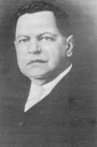

Preston Taylor (1849 –1931) was an African American businessman, Disciples minister, and philanthropist. Taylor was born in Shreveport, Louisiana, November 7, 1849 to slave parents, and was thus a slave himself. As a teenager he was employed as a drummer boy in the Union Army; he was granted his freedom for his services.
Following the Civil War he became a minister with the Christian Church and settled in Mt. Sterling, Kentucky about 1870. In 1874 he founded the High Street Christian Church.
In 1884, Taylor arrived in Nashville, Tennessee. He soon emerged as one of the city's most influential African American business and religious leaders.
Taylor was appointed minister of Gay Street Christian Church, which was the "colored" congregation associated with the Vine Street First Christian Church. In 1891 he and a breakaway group left the Gay Street church and established a church on Lea Street. Taylor was pastor of the church for 40 years, until his death in 1931.
Taylor established many businesses and programs in Nashville. Read more about him at http://ww2.tnstate.edu/library/digital/taylorp.htm

Join others to explore meditation practices
Garry Hesser is facilitating a new group study and practice of meditation. “Exploring and Practicing Approaches to Meditation and Contemplation” starts Thursday, February 25 before the SHMC board meeting. The format will be a “table talk” sharing of previous experiences and questions we each bring over light supper (bring a sandwich; drinks provided) from 5:15–6 pm, followed by guided meditation in the North Sanctuary from 6-6:45 pm. All are welcome!

SpringHouse family folk Dance on February 28
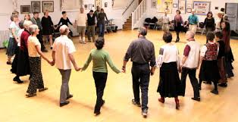
All ages are invited to a family folk dance event on Sunday, February 28 on the South Sanctuary wood floor. Easy to learn, easy to follow folk dances will be taught and led by our favorite caller, Robin Nelson. The programs will include folk dances from South America, as requested by the folks who went on the mission trip to Paraguay last summer. Lunch will be from 11:45-12:15, and the dancing will start at 12:15, finishing up at 1:45. For more information, please contact Rae Buzzell (raebuzzell@yahoo.com or 612-991-8351.

Reflections on the Word
Mark 10:51 – Then Jesus said to him, ‘What do you want me to do for you?’ The blind man said to him, ‘Teacher, let me see again.’

A new book examines the mind-body connection in medicine. A recent review of this book concludes: "If there is one lesson to be drawn from Cure [the book being reviewed], it is this: For the ailing, there is no substitute for face time with someone who cares about your fate." Jesus seems to have had an extraordinary ability to communicate to others, especially people in pain, that he cared about them. Showing people that we care is what Jesus calls us to do.
Loving God, Teach us to be attentive to the voices others ignore that we might respond with love. Amen
February 20, 2016
Page 6

Parábola de los labradores malvados
By Juan María Tellería Larrañaga
Narrative Lectionary
for February 28
Mark 12:1-2

A Welcoming Community of Faith in the Heart of the City
Ministry Team
Dan Adolphson, Associate Pastor
dan.adolphson@fccmpls.org
Julia Andrix, Faith Community Nurse
fcn@mpls.org
Rick Bowman, SHMC Building Manager
Serena Chial, Nursery Attendant
Adam Contad, Music Director
Pamela Cook SHMC Director of Youth
springhouseyouthdirector@fccmpls.org
Laurie Pound Feille, Senior Minister pastor@fccmpls.org
Yunyue Liu, Keyboardist
Martha Harris, Courier Editor harrismartha@mac.com
Deb Murphy, Office Manager and Director of Spiritual Formation for Children & Youth
deb.murphy@fccmpls.org;
& SHMC Building Use Coordinator
events_SHMC@fccmpls.org
Office Telephone: 612.870.1868
www.fccminneapolis.org
E-Mail: office@fccminneapolis.org
Next Courier: March 5, 2016

First Christian Church (Disciples of Christ), Minneapolis, is a partner church at SpringHouse Ministry Center
Sundays at First Christian Church
Worship at 10:30
Before Worship: After Worship
Spiritual Formation Classes: 11:45 Fellowship Time
9:00 Hearthstone Class,
9:15 Children’s Classes;
Adult Class: continuing book study

First Christian Church of Minneapolis (Disciples of Christ)
610 W. 28th Street
Minneapolis, MN 55408

