The COURIER
September 12, 2015

Joint Service, Concert launch fall SH season

  - What’s INSIDE:

Voices and Views from Pastor Dan, page 2

Sunday School and other volunteers needed,
page 3

Books, books books,
page 3

UPCOMING Events:

FCC Board Meeting, Tuesday, Sept. 15, 7 pm

Worship Committee meeting,
Tuesday, Sept. 15, 6 pm

Pat Carter Recognition, Sunday, Sept. 20, following worship
The fall season at SpringHouse starts this Sunday, September 13, with a Joint Service to celebrate the start of the new fall children’s Sunday School curriculum.
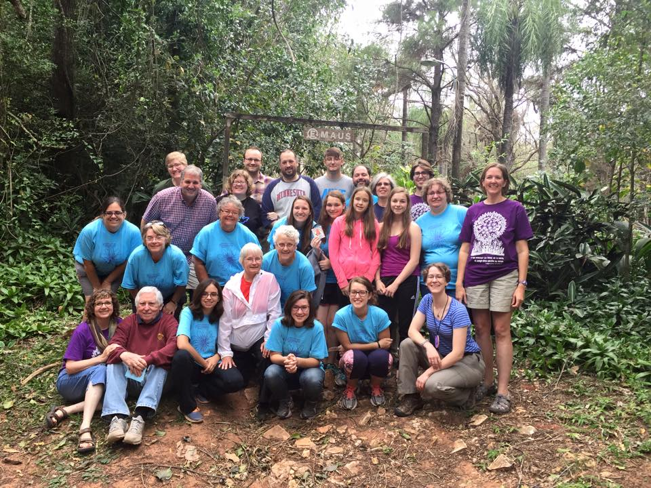
But that’s not all! Members of the “Destination: Paraguay” mission group will provide some reflections, photos and music about their trip during the service.

Following the service, there will be a potluck picnic lunch and then singer Dennis Warner will present a concert, the first offering of the new “Arts at First Performance Series” that will bring us special music events throughout the year. Dennis’ performance will be at 12:45 in the South Sanctuary – and it’s free!
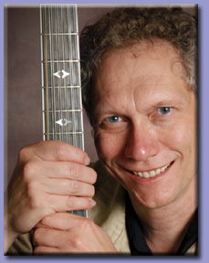

So, don’t miss this special Sunday. Bring a friend!
Folk/Americana musician and entertainer Dennis Warner performs in over 100 cities each year. Beads on One String, his fun, up-tempo song about how “we’re more alike than we are different” became an illustrated children’s book – which became the core of an elementary school curriculum. We give this book at children’s dedications. Warner’s CD Seeds was a top rated folk album in 2012.

Page 2
September 12, 2015

Prayers of Joy
For Earl and Valerie Dunham’s 51st Wedding Anniversary
For Mark Carlson’s new job

Prayers for new starts
For Brooke Apple as she begins her new internship in Dawson, MN
For all students and teachers starting a new school year

Prayers for Healing
For Wesley Kaake’s father, undergoing surgery
For Athena Carlson’s friend Frank
For all our homebound members including June Andrix and Donald Ulm.

Prayers for the World
For communities across the nation torn by violence against police and against citizens
For the thousands of displaced people seeking better and safer lives for their families

In Our Prayers
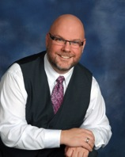
Voices and Views
Pastor Dan Adolphson

Sharing a wonderful gift

In our life journey, there are always the unexpected twists and turns. Sometimes, those unexpected turns can become the greatest gift imaginable. Earlier this summer, I received just such a gift, one that I want to share with you.

You may not know that I was adopted. It is something I have known as far back as memory takes me. When I graduated from high school in 1985 and started college, I needed to have my adoption file opened, and the information I learned that day added to the questions I had about who I really was and what led to my adoption. A law change in Washington State in 2013 added to the wrestling, and, after much prayer and discussion, I began the search this past spring for information about my birth family. It involved two state departments of health and historical records, and a lot of searching through sites like Ancestry.com and geni.com. Laurie helped me each step of the way – she is a whiz with these sites and also helped me weigh each step and the emotions that came with the unpeeling of the layers.

The search culminated on July 10, when I received a phone call from my birth mother! (I was expecting an email or a letter; a phone call I was not prepared for!) This began a beautiful and overwhelming 24 hours, in which I gained a new family – my birth family!

So, about my family. My mom is a retired college professor in education and gender studies from Chapman University, one of our Disciples of Christ institutions. She lives with her wife in the mountains above the San Fernando Valley in California. I have two brothers – one in Idaho and one in New Mexico, and one sister in California, who Keith and I met three days after Mom called me. There is also a half-sister to them in Idaho who considers me her new brother. You will get to meet Mom later this month.

You may be wondering how this affects my relationship with my adoptive family, especially in regards to the continued decline of my mother. I am in the process of having conversation with selected members and would appreciate your prayers.
Neither family replaces the other; my mom gave my parents the beautiful gift of a son, and that gift has come full circle.
Step up and volunteer! Lots of SH opportunities for you

The new Sunday morning book study starts September 13 at 9:15. Pre-Post-Racial America: Spiritual Stories from the Front Lines by Sandhya Rani Jha recasts the difficult conversation about race and faith in a way that is grounded in real people’s stories. For those who cannot come on Sunday mornings, there will be a monthly gathering to discuss the book.

FCC’s book club starts the fall season with Maine by J. Courtney Sullivan. The group will meet October 1 at 7 pm at SpringHouse to discuss this “wickedly funny” book about three generations of women who converge on a family beach house.

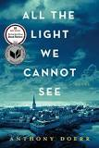
All the Light We Cannot See, the award-winning best seller by Anthony Doerr will be Book Club’s topic on Oct. 26 when they meet at Val Dunham’s at 7 pm. The book club is open to everyone – come once or come every month!
Books, Books, Books
Page 3
The Courier

The Child Ministry Team is looking for “shepherds” and “wise ones” to help present the Sunday School program to SpringHouse children. This year’s Bible study theme is “Kid Power in the Bible.” Every three weeks, the children will focus on a particular story through various lenses: drama, art, outdoors, cooking or other activities that relate to the story.

“Wise Ones” are resource people that plan the lessons and teach. They are responsible for one lesson plan for three weeks that can be taught to all three classes - one age group each week. The commitment is for three weeks at a time and enthusiasm to plan and implement lessons.

“Shepherds” are the folks that provide continuity for the classes from week to week throughout the year. They are responsible for showing up (every week, or with regularity) and helping with activities, but do not do planning or teaching.

The Child Ministry team also plans to have occasional Inter-generational weeks (in between the three week rotations) and would love volunteers and participation in these activities.

Rae Buzzell and Emma Jorstad , both from Salem, are this year’s co-directors. Contact them or Deb Murphy if you would like to volunteer to help out.

First Saturdays is looking for a few good cooks! We are looking for people to provide meals on the first Saturday each month starting in October and running through June. This is a great way for you to get involved with our LGBTQ youth community partnership program. It can be one person, or a couple of people, or a group. Talk to Kirsten Cackoski or Pastor Dan for information or to sign up.

Brooke and Sammie say goodbye
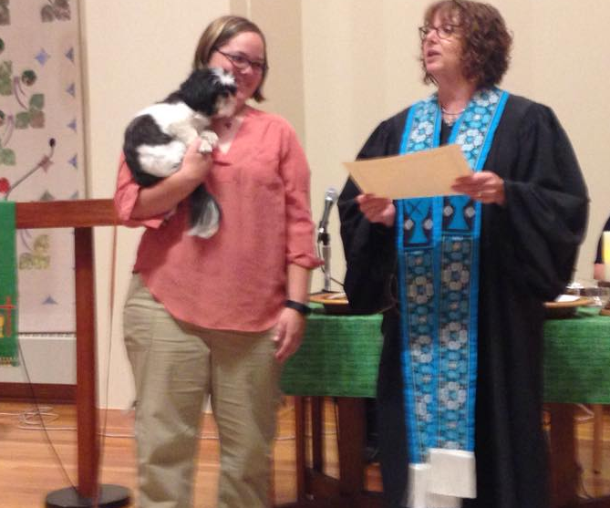
Brooke Apple, our SpringHouse Ministry Center Youth Minister, is leaving to do her internship year at Grace Lutheran Church in Dawson, MN. We said goodbye in worship by making her an honorary member of FCC; we deeply appreciate all that she has done for our youth and how she has woven herself into our hearts. Good luck and Godspeed!

Reflections on the Word
John 21: 17 “ He said to him the third time, ‘Simon son of John do you love me?’. . . Jesus said to him, ‘Feed my sheep,’”
To the puzzled apostle Peter, Jesus repeats three times: “Do you love me? Feed my sheep.” Implied in this question and statement is an “if – then”: If you love me, then feed my sheep. Jesus is telling Peter and telling us that our faith and love are best expressed in action and community.

Loving God, Help us learn to love you more, to know that you forgive us, and to understand that we show our love when we care for others. Amen.
April 11, 2015
Page 4
January 10, 2014
Page 4

Sundays at First Christian Church

Worship at 10:30

Before Worship After Worship
Children’s Classes, 9:15 am Fellowship Time 11:45
Hearthstone Class, 9 am
Adult study 9:15 am

First Christian Church of Minneapolis (Disciples of Christ)
610 W. 28th Street
Minneapolis, MN 55408

First Christian Church (Disciples of Christ), Minneapolis, is a partner church at SpringHouse Ministry Center
Narrative Lectionary texts for Sunday, September 13
John 21: 15-19

A Welcoming Community of Faith in the Heart of the City
Ministry Team
Dan Adolphson, Associate Pastor
Julia Andrix, Faith Community Nurse
Brooke Apple, Youth minister
Rick Bowman, SHMC Building Manager
Serena Chial, Nursery Attendant
Adam Conrad, Director of Ensembles
Laurie Pound Feille, Senior Minister
Nate Lien, Child Care worker
Leah Siltberg Froehlich, Music Director
Martha Harris, Courier Editor
Deb Murphy, Office Manager and Director of Spiritual Formation for Children & Youth; SHMC Building Use Coordinator
Office Telephone: 612.870.1868
www.fccminneapolis.org
E-Mail: office@fccminneapolis.org
Christian Courier is published bi-monthly. Send items and ideas to church office or to Martha Harris
harrismartha@mac.com
Next issue is September 26.

